**Selecting a VM from the catalog**

I selected the [Solr 4.0.0-0 (Ubuntu 12.10)](http://lucene.apache.org/solr/" \o "Solr is the popular, blazing fast open source enterprise search platform from the Apache Lucene project." \t "_blank) image from the [catalog](http://vmdepot.msopentech.com/List/Index) available on VM Depot and clicked on the **Deployment Script** button at the top of the page.

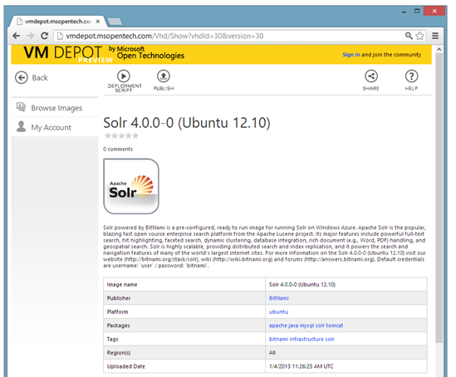

After selecting the Deployment Region from the drop down, I was presented with a command line script to create my Solr virtual machine. Keep this handy.

|  |  |
| --- | --- |
| 1 | azure vm create DNS\_PREFIX -o vmdepot-30-1-1 -l "West US" USER\_NAME [PASSWORD] [--ssh] [other\_options] |

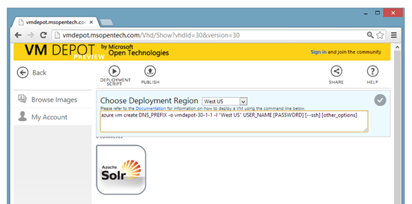

**Create a storage account**

We’ll need to create a storage account that hold the virtual machine’s OS Disk ([vhd](http://en.wikipedia.org/wiki/VHD_(file_format)" \o "VHD (Virtual Hard Disk)" \t "_blank)). Type the following at the command line, replacing $REGION with the data centre region you have selected and $VMNAME with the dns name you are giving your virtual machine.

|  |  |
| --- | --- |
| 1 | azure storage account create --location "$REGION" "$VMNAME" |
|  |  |

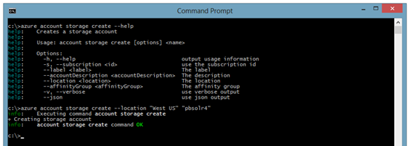

You can see that I have chosen the **West US** as my region and **pbsolr4** as the dns name for my virtual machine. You can also confirm the creation of the storage account in the portal.

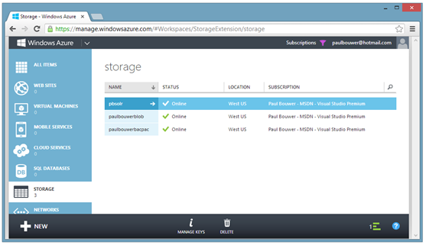

To ensure that this storage account is used for your virtual machine, set it as the default storage account for the interactions to follow on the command line.

Type the following at the command line, replacing $STORAGEACCOUNT with the name of your storage account. You can see that my storage account name is **pbsolr4**.

|  |  |
| --- | --- |
| 1 | azure config set defaultStorageAccount "$STORAGEACCOUNT" |

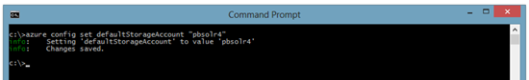

**Creating the VM**

We’ll now use that command line script that the VM Depot site gave us to run as a deployment script. I’ll repeat it here.

|  |  |
| --- | --- |
| 1 | azure vm create DNS\_PREFIX -o vmdepot-30-1-1 -l "West US" USER\_NAME [PASSWORD] [--ssh] [other\_options] |

I ran the command line script with an additional parameter **–vm-size small**to specify my virtual machine size. My complete command line script is as follows:

|  |  |
| --- | --- |
| 1 | azure vm create pbsolr4 -o vmdepot-30-1-1 -l "West US" paul --ssh --vm-size small |

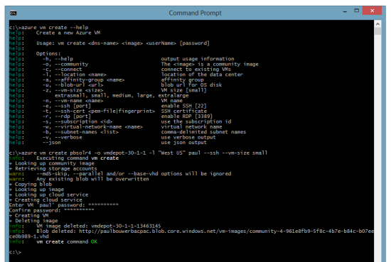

Unlike the Powershell cmdlets which honour my default storage account, it seems as if the Windows version of the command line tools has decided to use the first storage account (**paulbouwerbacpac**) it found in my subscription and not the storage account I specified ! Hope this gets fixed sometime.

You can see the image copied from VM Depot under the Images tab of the Virtual Machines section in the portal. As can be seen from the command line output above, this image is deleted once the virtual machine creation is complete.

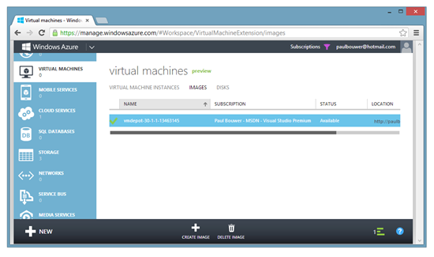

If you have a look at the Disks tab of the Virtual Machines section in the portal, you’ll see the OS Disk (vhd) once your virtual machine has been created.

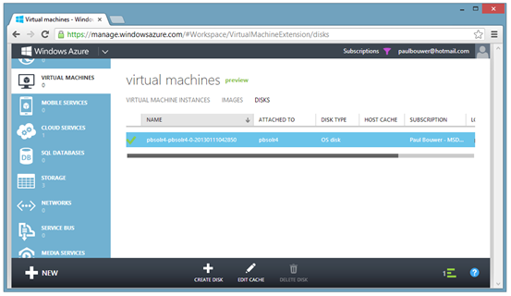

And finally, the virtual machine is running. This can be confirmed via the portal.

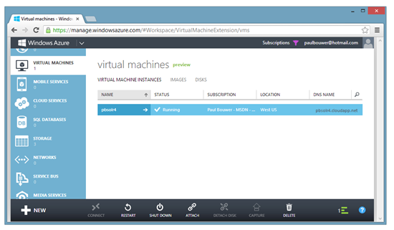

**Create http endpoint**

Typing the following at the command line shows that our ssh public endpoint has been created as per the **–ssh**switch when we created out virtual machine.

|  |  |
| --- | --- |
| 1 | azure vm endpoint list pbsolr4 |

Solr is web based so we’ll need to add an http public endpoint too. Typing the following at the command line will result in a public endpoint being created on port 80 which will be routed internally to port 80 and will have a name of http.

|  |  |
| --- | --- |
| 1 | azure endpoint create pbsolr4 80 80 --endpoint-name "http" |

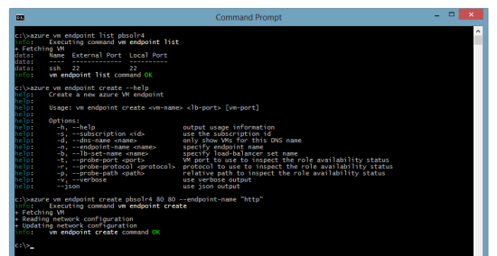

The creation of this new endpoint can be confirmed in the portal by browsing to the Endpoints tab of our virtual machine.

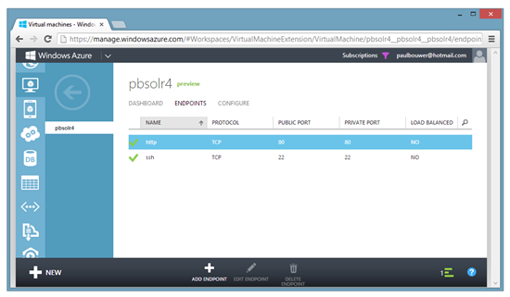

**It’s running !**

Browsing to **pbsolr4.cloudapp.net/solr**returns the Solr dashboard. Solr is up and running and our public endpoint on port **80** (http) is working.

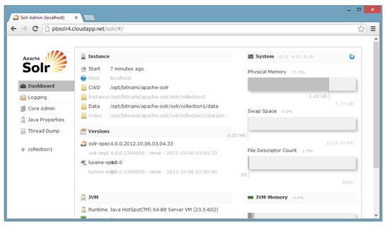

I can also SSH to **pbsolr4.cloudapp.net** on port **22** (ssh).

